The Beatles – All together now
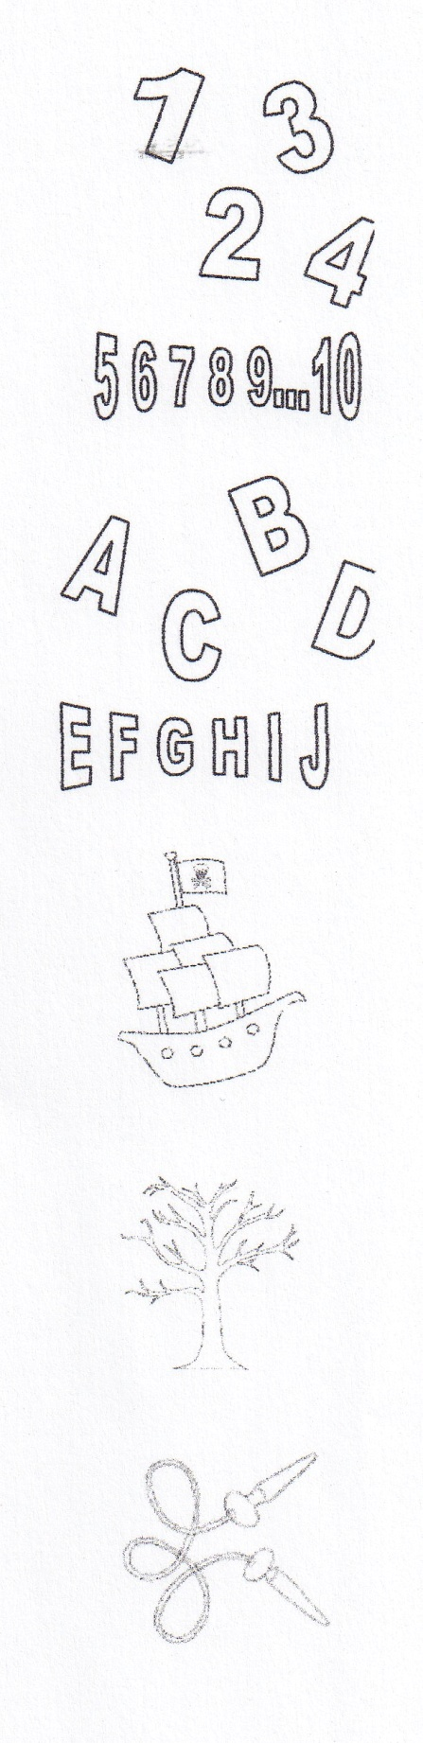
_______, two, _______, four
Can I have a little _______?
five, six, seven, _______, nine ten I _______ you.
_______, _______, _______, _______
Can I bring my _______ to _______?
E, _______, G, _______, I, _______, I love you.
Boom, bam, boom
Boom, bam, boom
Sail the _______,
Boom, bam, boom
Chop the _______
Boom, bam, boom
Skip the rope,
Boom, bam, boom
_______at me
All together now.... (x16)
_______, _______, _______, red
Can I take my friend to _______?
Pink, _______, yellow orange and blue I love you
Sail the _______,
Boom, bam, boom
Chop the _______
Boom, bam, boom
Skip the rope,
Boom, bam, boom
_______ at me
All together now....

