American Currency
Coins 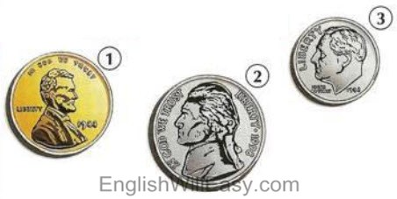 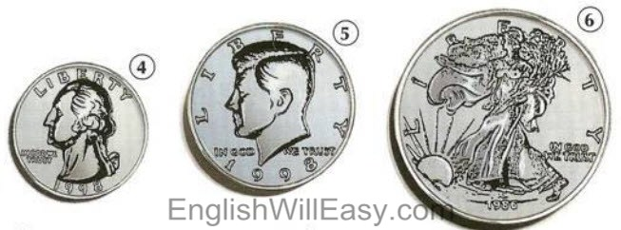

1. $.01= a penny = 1 cent
2. $.005= a nickel = 5 cents
3. $.10= a dime = 10 cents
4. $.25= a quarter = 25 cents
5. $.50 = a half dollar
6. $1.00 = a silver dollar
Bills
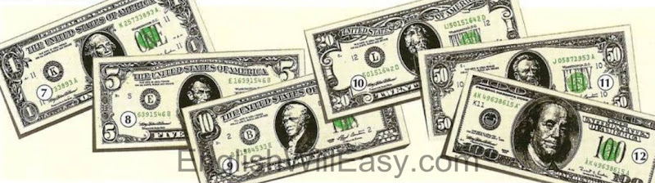

7. $1.00 a dollar
8. $5.00 five dollars
9. $10.00 ten dollars
10. $20.00 twenty dollars
11. $50.00 fifty dollars
12. $100.00 one hundred dollars

Other Vocabulary

To buy =
To cost =
To earn =
To pay =
To spend =
To save =
To borrow =
To lend =
To pay back =
To give =
To owe =
To withdraw =
Account =
Bills / Notes =
Cash =
Cashier =
Cash machine / ATM =
Coin =
Change =
Credit card =
Check/cheque =
Currency =
Money =
Price =
Purse =
Wallet =

British Currency
Coins
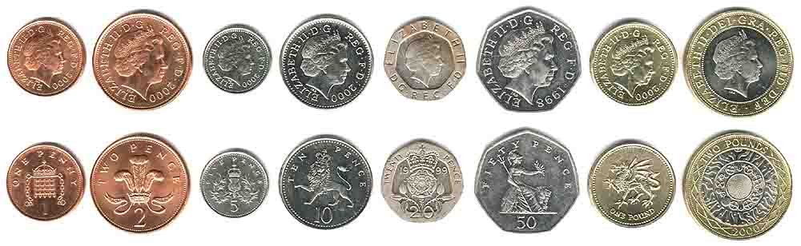
Heads  Tails | A one penny coin | A two pence coin | A five pence coin | A ten pence coin | A twenty pence coin | A fifty pence coin | A one pound coin | A two pound coin

Notes
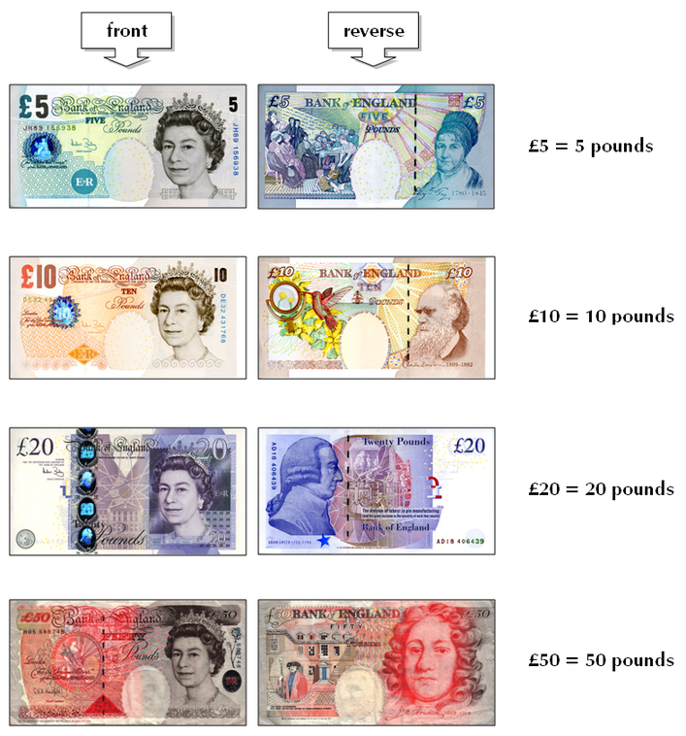
Connect sums with the right amount
$0.25 eleven dimes and a nickel
$1.15 a quarter
$10 one hundred dollars
$100 ten dollars
$0.77 one dollar
$1 three quarters and 2 pennies
$ 0.80 fifteen dollars
$15 eight dimes
Write an equivalent of the given amount
- 1 dollar = ……………. dimes
- 5 dollars =……………. quarters
- $0.55 =………… dimes and …………….. nickel
- 2 dollars =……………. nickels
- $2.03 =………………...quarters and ………… pennies

Now write each amount using numbers
1. one five, twelve one dollar bills and a quarter = ______$17.25____
2. two nickels and 5 pennies……………………………..
3. 3 quarters and 2 dimes…………………………………
4. five tens and 2 quarters……………………………..
5. a half-dollar and 4 nickels………………………………..
6. a ten dollar bill and twenty-two pennies……………………...
7. two twenties, six fives, two ones and a half dollar= ………………………………

