VIDEOGAMES

Videogames are one of the most popular forms of entertainment.
- Do you like videogames?
- How often do you play videogames?
- Do you play on the computer, on a games console or on the mobile phone/tablet?
- What is your favourite type of videogames?
- Match these videogames covers with their genre:
Platform game | Shooter | Survival horror | Sports game
RPG (Role Playing Game) | Puzzle game | Music game | Racing game
Party game | Pinball game | Fighting game | Simulation game

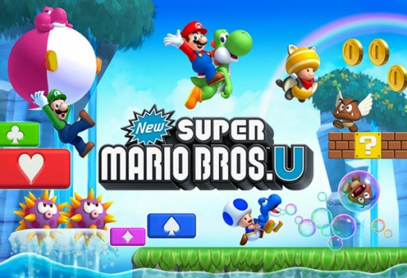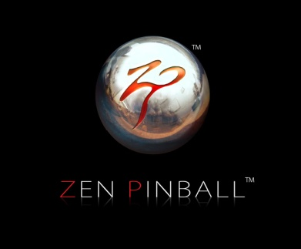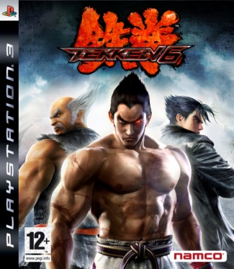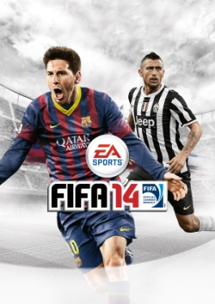
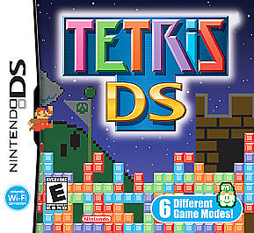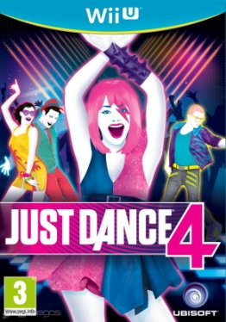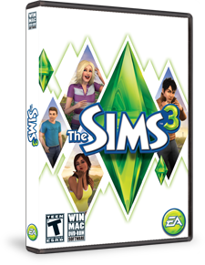
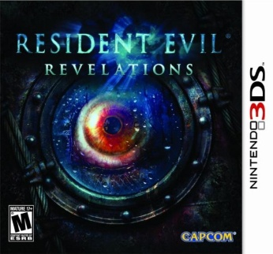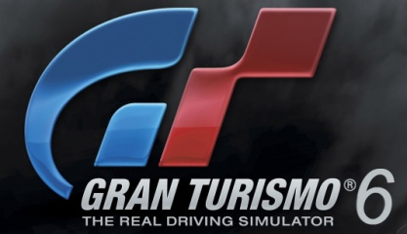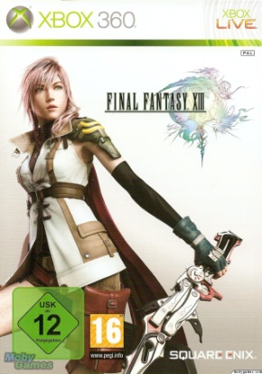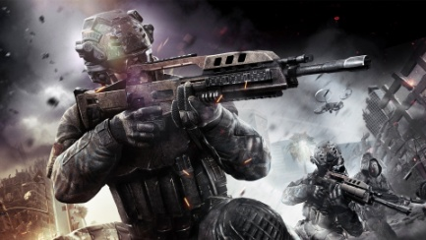
Do you agree or disagree with these statements about videogames?
- Playing to much videogames can be dangerous for your health.
- Sports videogames are more exciting than playing actual sports.
- Videogames can be good for the brain.
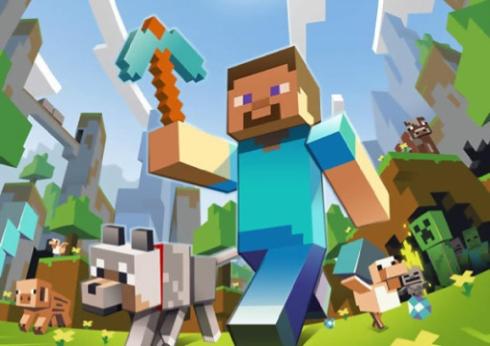
- I only play videogames at the weekends.
- Videogames are for boys only.
- Adults don’t play videogames.
- I usually make pauses when I play a lot of time.
- Some videogames are for girls only.
- Violent games make violent people.
- You can learn how to drive with videogames.
- Videogames can be used for education.
- Videogames based on films are usually very bad.
- I prefer playing with a joystick rather than a touch screen.

Minecraft is a popular open world game. Players can create anything they want using blocks. They also can “craft” or build tools and objects with the materials they get in the world. The game was released in 2009.
The creator has earned more than a hundred million dollars. He started the game independently, without almost any help. His father was very bad to him but he is a creative person and decided to move on.
- Imagine you can get an interview with Markus `Notch´Persson, the creator of the game. What would you ask him? Think of 3 questions

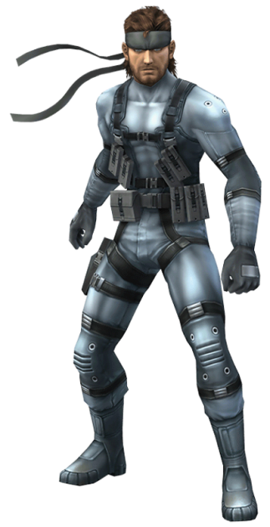
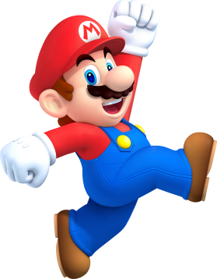
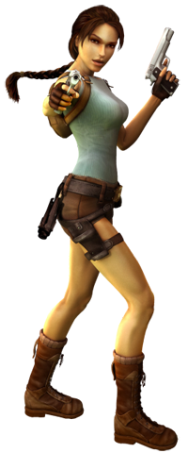
Some videogame characters have become icons of the modern age. Do you know “how old” are these characters? When was their first game released? Match the years with the characters.
Mario (Super Mario Bros.) | 1986
Solid Snake (Metal Gear) | 1987
Lara Croft (Tomb Raider) | 1981
Link (The Legend of Zelda) | 1991
Sonic (Sonic) | 1996
Master Chief (Halo) | 2001
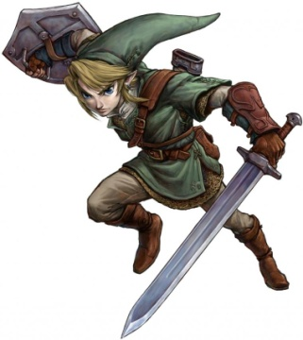
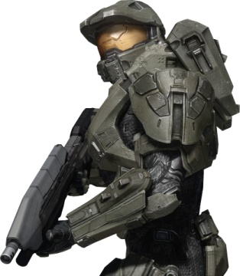

Videogame characters are often in dangerous situations. But they also have a normal life after their adventures. Do you know the real jobs of these characters?
Mario | Archaeologist
Lara Croft | Bounty hunter
Samus Aran (Metroid saga) | Treasure hunter
Nathan Drake | Police officer
Chun-Li | Plumber

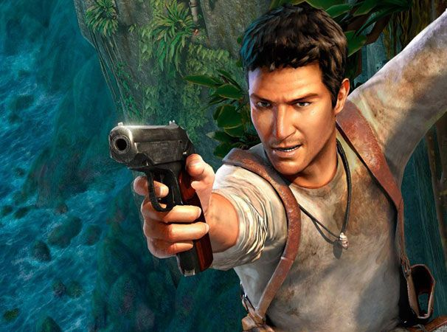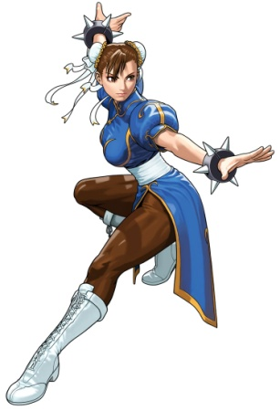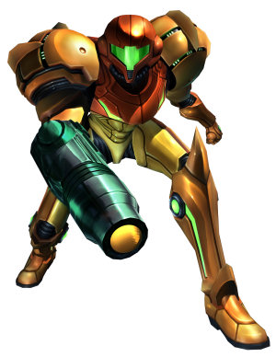

Most videogame superheroes have sidekicks or friends who help them fight against their enemies. Are these characters friends or enemies?
Sonic | Tails | Dr Eggman | Amy Rose
Mario | Bowser | Peach | Luigi | Toad | Wario
Pac-Man | Ms Pac-Man | Blinky | Pinky
Link | Ganon | Zelda | Epona
Pokémon Trainer | Pikachu | Mum | Team Rocket | Professor Oak
Donkey Kong | Diddy Kong | Cranky Kong | Dixie Kong | K. Rool

Mario has been one of the most popular characters in the videogame history. He started as an enemy in Donkey Kong and his name was just Jumpman. Look at the picture and describe the characters. What is their relationship? What is their occupation? What colour do they usually wear? And their powers?
