Name ______________ Number____ Class___

Breakfast Lunch Dinner
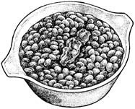
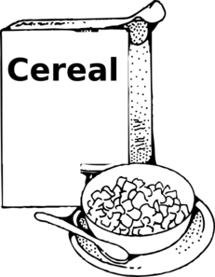
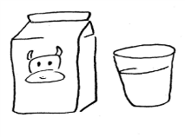
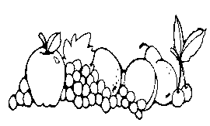
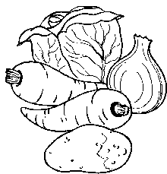
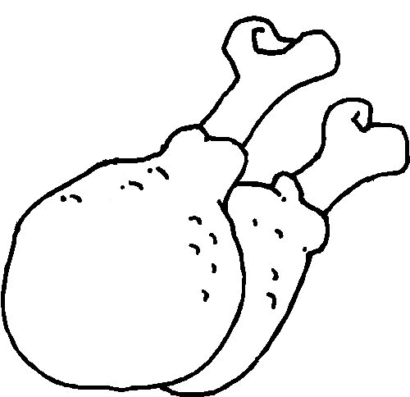
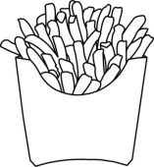
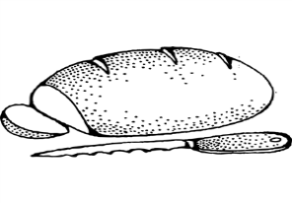
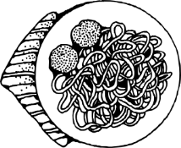
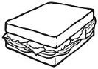
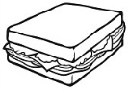

e.g. I have cereal with milk for breakfast.

I have _________________________________ for breakfast.
_______________________________________ for lunch.
_______________________________________ for dinner.

My friend has _______________________________________.
__________________________________________________.
__________________________________________________.

cereal spaghetti rice fruit chips chicken meat
bread beans milk vegetables sandwiches

