St. Pratick’s Day- Irish symbols

- Match the definitions with the symbols.

- a plant with three round leaves in a triangular pattern.
- A symbol of success, happiness.
- a march or public celebration.
- magical creatures, mischievous little old men.
- a hot drink made with cream.
- a traditional stringed instrument.
- colours seen in arcs in the sky.
- a symbol often seen made of silver, stone a or as a tattoo
- a traditional Irish dance event

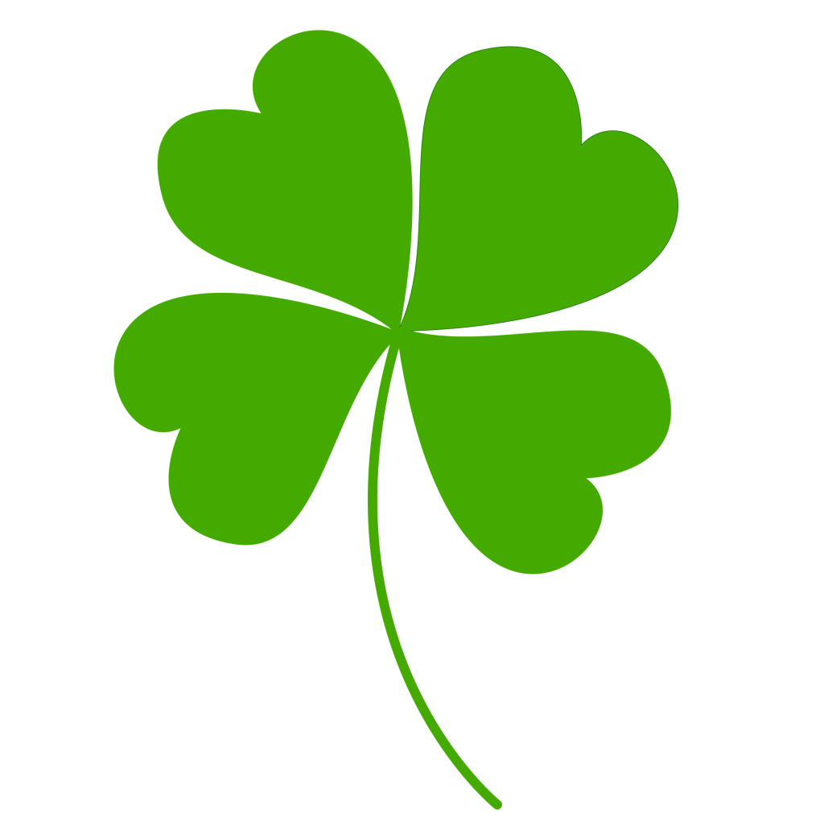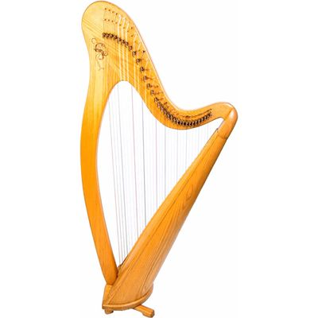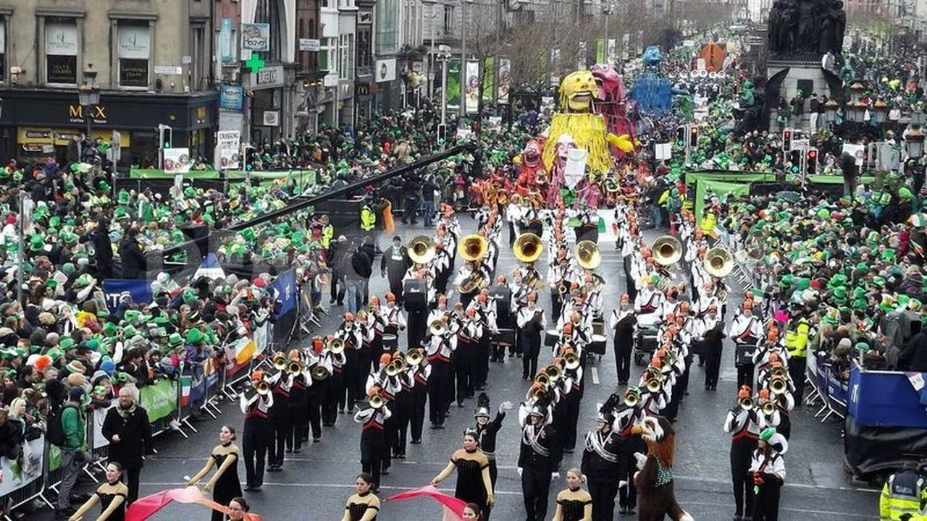
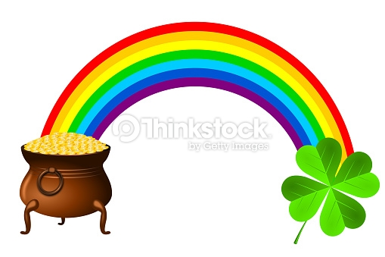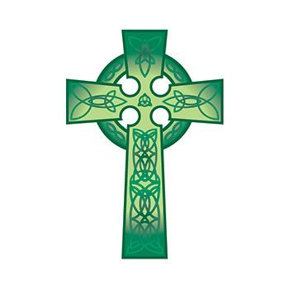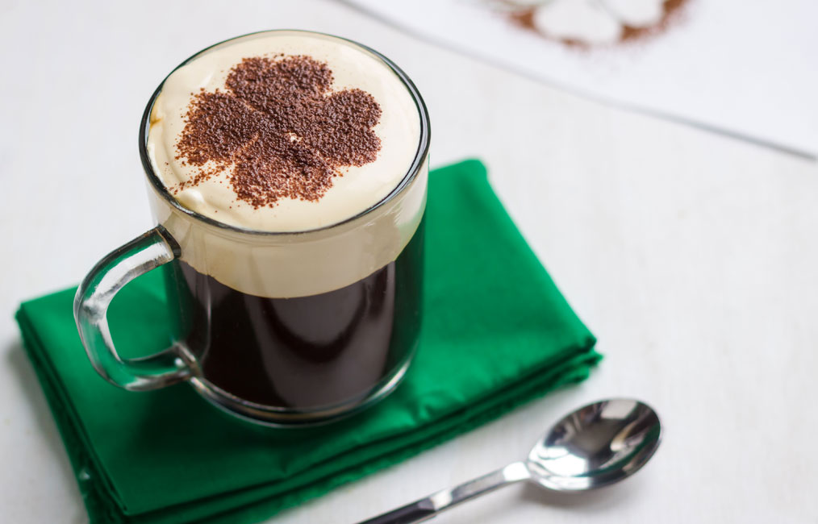
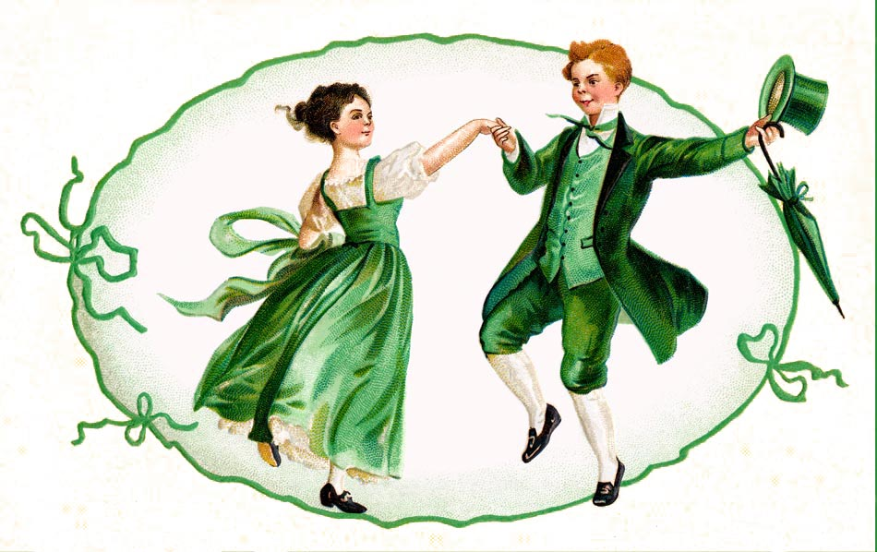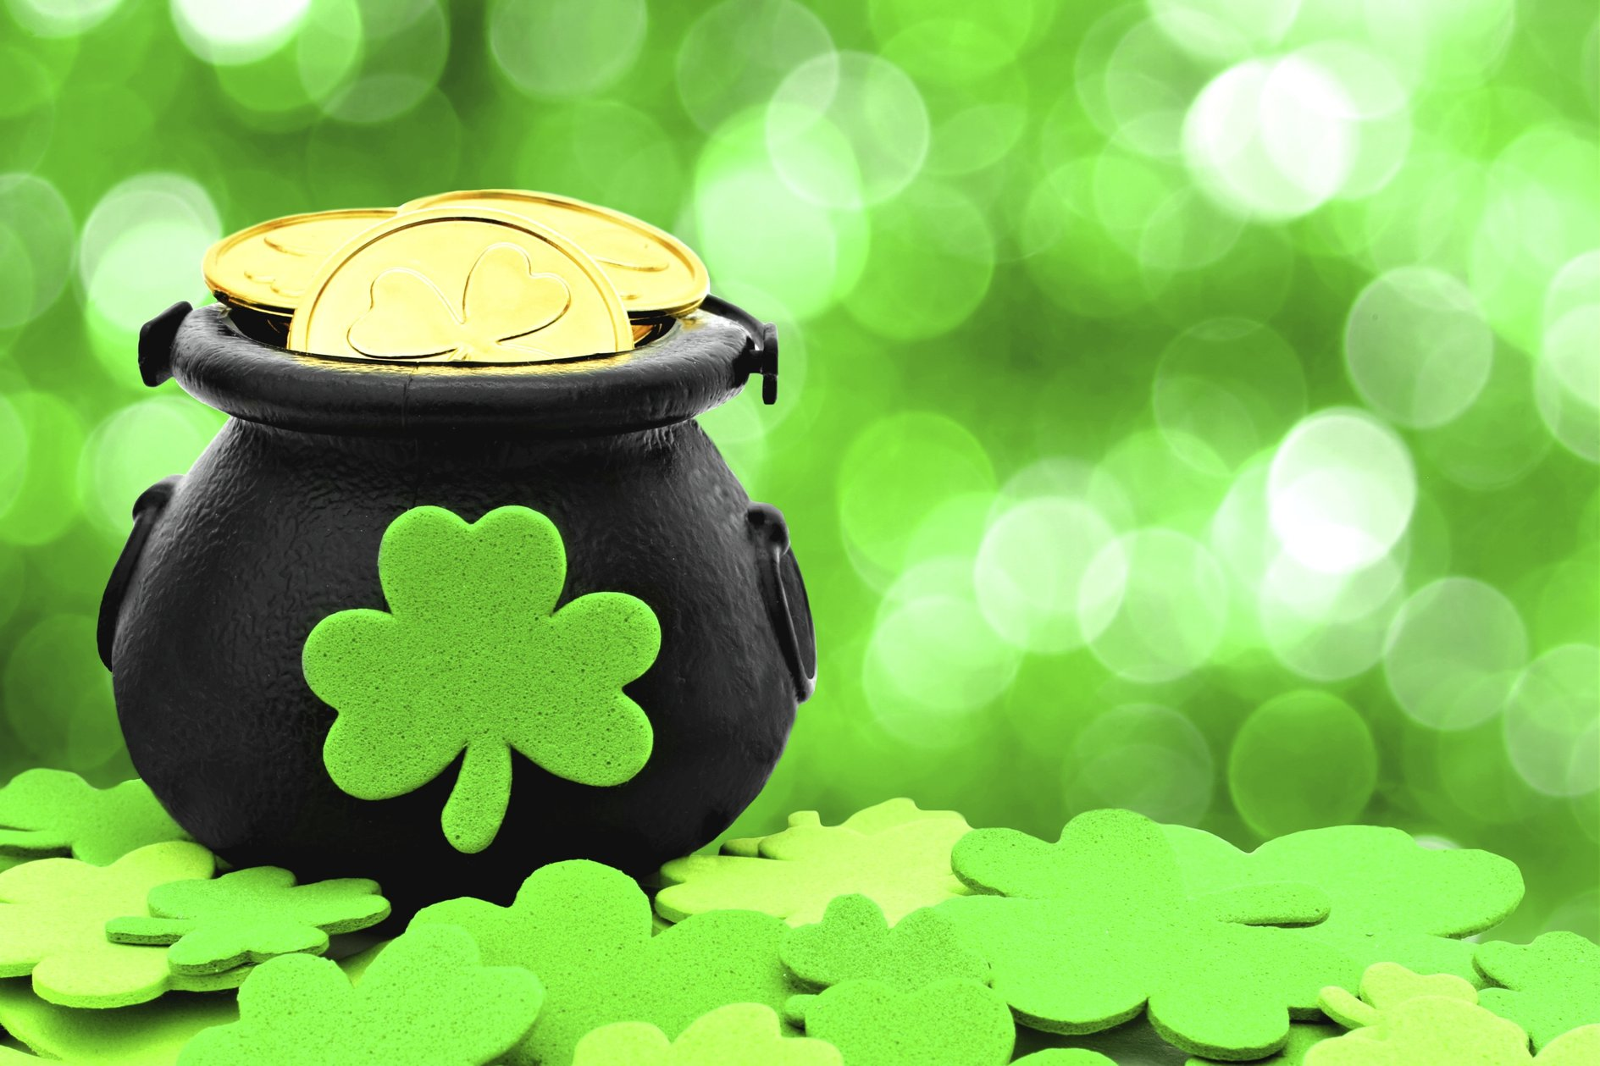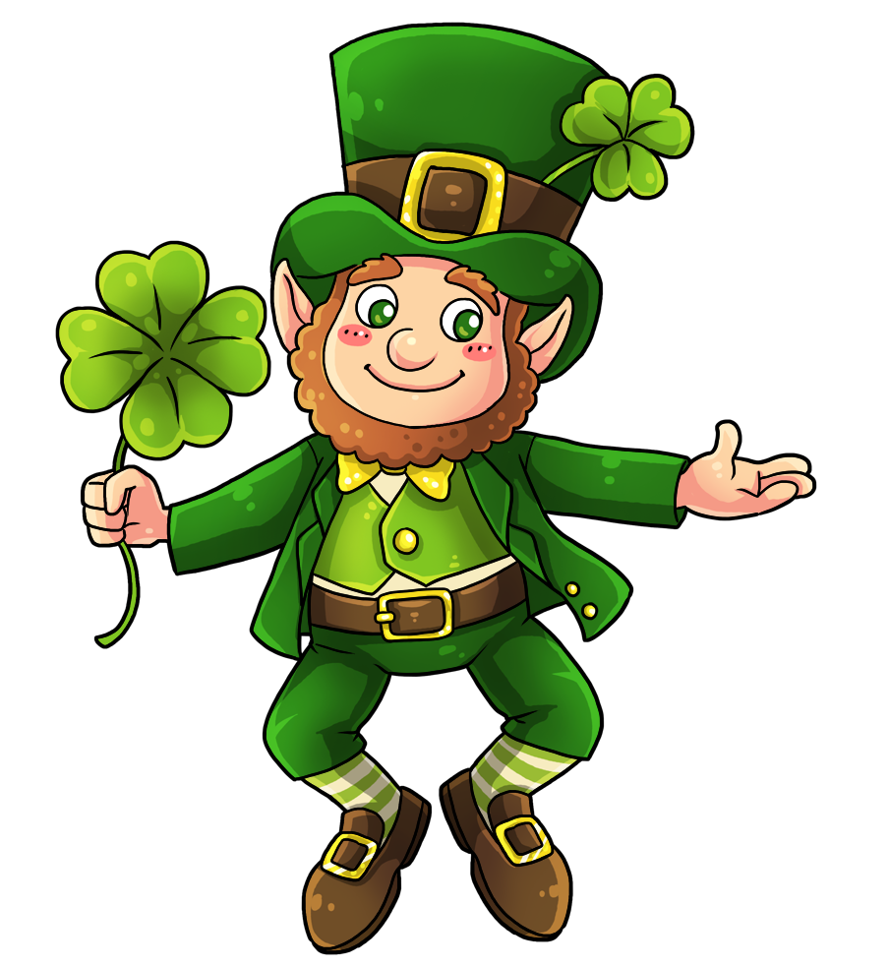

SYMBOLS: CROSS, IRISH DANCE, IRISH COFFEE, LEPRECHAUN, PARADE, RAINBOW, HARP, POT OF GOLD, SHAMROCK.

